FBLA API Documentation

Yi Zhao

Entity Base Class:

The entity base class can be used to create anything that is affected by gravity. There are 4 implemented physics: gravity, bounce, friction and slide

Configurable options:

* Gravity:
  + gravityEnabled:Boolean – toggle gravity
  + gravityBasePower:Number – Specifies gravity strength
  + gravityIncreaseMultiplier:Number – Specifies amount to increase gravity
* Bounce:
  + bounceEnabled:Boolean – toggle bounce
  + bounceBackHeight:Number – Specifies amount of fall to bounce: if fell from 10, a bounceBackHeight of .5 would lead to a bounce height of 5.
  + bounceBasePower:Number – Specifies bounce strength
  + bounceIncreaseMultiplier:Number – Specifies amount to increase/decrease bounce power
* Friction
  + frictionEnabled:Boolean – toggle friction
  + frictionMuliplier:Number – toggle amount of decrease x movement
* Slide
  + slidingEnabled:Boolean – toggle slide
  + slideDecreaseMultiplier – decrease in amount of distance slid
* Other
  + protected onGround:Boolean – specifies if entity is onGround
  + protected movex, movey : Number – change these to determine x and y movement.
  + function entity_update() – function that processes everything

Example of how to use Entity:

To demonstrate how to use the entity base class, we will be creating a new object called Ball, which will be moved with the mouse.

Instructions:

1. 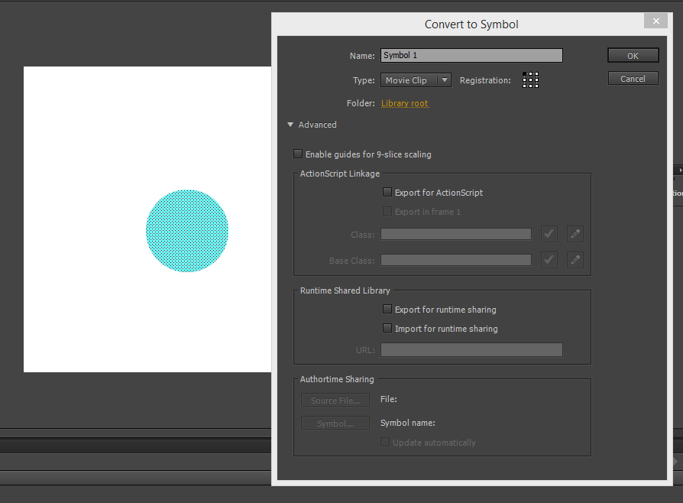Draw your object to screen and press “Convert to Symbol”:
2. 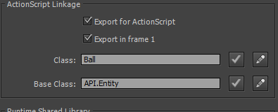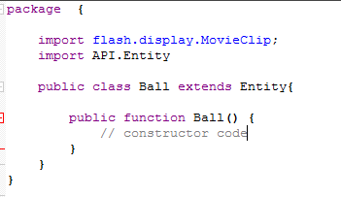Check export to actionscript and fill in the following options:
3. Press the pencil button and it should take you to a code editor screen, import API.Entity and instead of “… extends MovieClip”, change it to “… extends Entity”:
4. 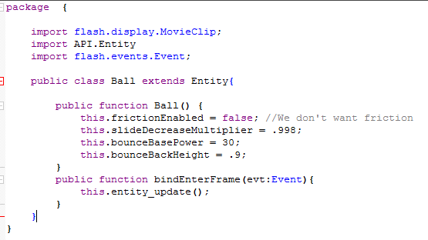Now type the following options in the constructor and create a new function:
5. 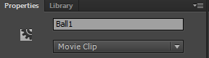Go on to the stage, click your ball and give it an instance name:
6. Finally, go to frame actions and type the following line:
   1. Ball1.addEventListener(Event.ENTER_FRAME, bindEnterFrame);
7. This is a basic version of ball, it is up to you to expand the class to improve movement with arrow keys/mouse.